SF.SmokeTest_Manager_TC_SF_ManagerLogin_Instance1_12-Apr-2017_10-28-18_AM_Invoke_Application.png



SF.SmokeTest_Manager_TC_SF_ManagerLogin_Instance1_12-Apr-2017_10-28-29_AM_Login.png

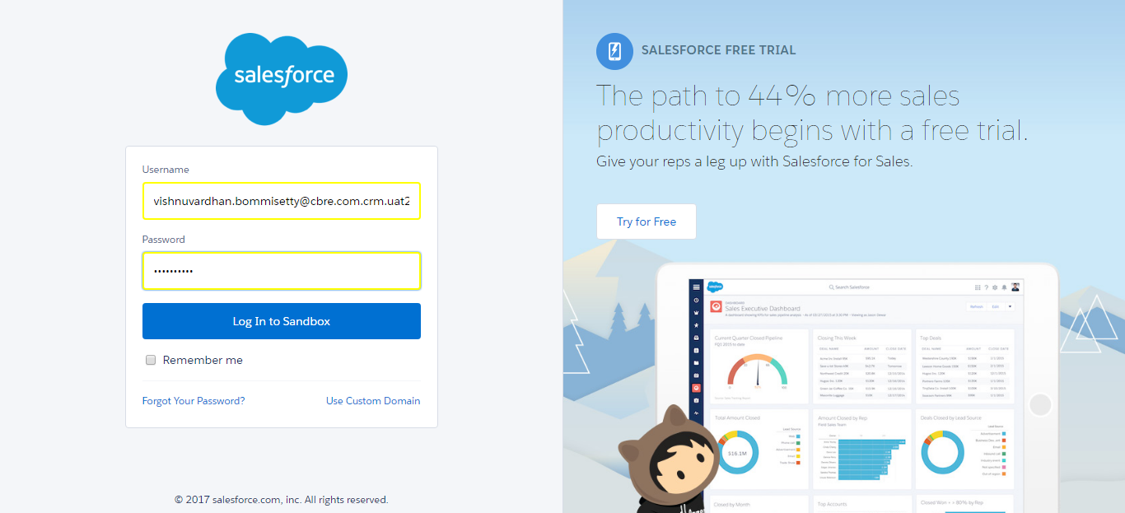

SF.SmokeTest_Manager_TC_SF_ManagerLogin_Instance1_12-Apr-2017_10-28-31_AM_Error.png

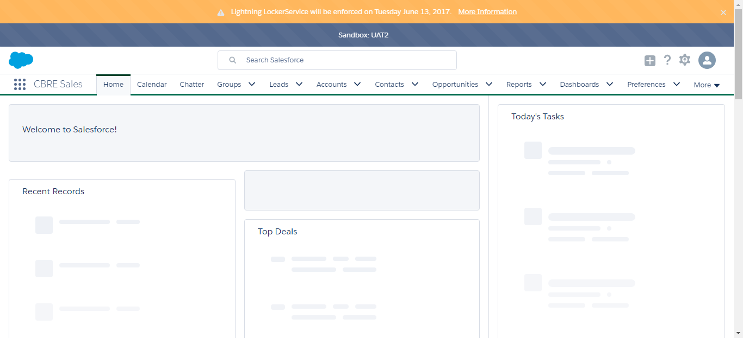

SF.SmokeTest_Manager_TC_SF_ManagerLogin_Instance1_12-Apr-2017_10-28-44_AM_Invoke_Application.png



SF.SmokeTest_Manager_TC_SF_ManagerLogin_Instance1_12-Apr-2017_10-28-51_AM_Login.png

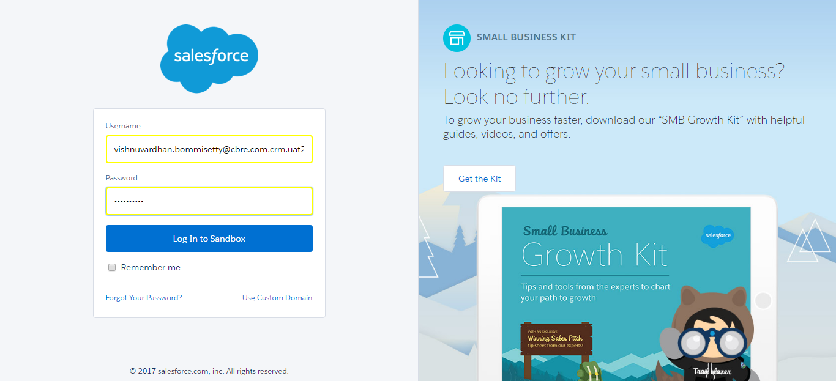

SF.SmokeTest_Manager_TC_SF_ManagerLogin_Instance1_12-Apr-2017_10-28-54_AM_Error.png

